Parish Toolkit: Diocesan-Wide Planning Feasibility Study
Are you a parish administrator or leader? We need your help to tell your community about the diocesan-wide Planning Feasibility Study and opportunities for input. This parish toolkit includes copy-and-paste announcements for the pulpit, bulletin, emails, and social media!
Key URL Links
- Planning Feasibility Study Webpage
- Letter to the Diocese from the Bishop
Pulpit Announcement
A message to read during your Sunday announcements
Our diocese recently completed Cast the Net, a visioning process that heard the needs and ideas of more than a thousand clergy and lay leaders. 20 Calls to Action emerged on how we can embrace God’s future together. How we respond to these calls will look different in every parish. How do we want to live them out in our community? What resources will best support us – today, in five years, in ten years?
To explore these questions, we are embarking on a diocesan-wide Planning Feasibility Study to prayerfully discern our collective readiness for a potential fundraising campaign that will serve and strengthen our parish and our broader diocesan community.
All Anglicans in the Diocese of Toronto are invited to share candid feedback on a Preliminary Case for Support by participating in one of several open forums taking place this coming March. Details can be found in our bulletin.
This study is our opportunity to dream about the possibilities of ministry within our parish and across our diocese. I encourage you to participate if you are able.
Bulletin and Email Announcement
Copy-and-paste into your bulletin and parish email/newsletter
Have Your Say! Participate in Diocesan-Wide Planning Feasibility Study
Twenty Calls to Action emerged from Cast the Net, a visioning process that heard from more than a thousand clergy and lay leaders. Responding to these calls will look different in every parish, and will require resources and financial supports. Together, we are embarking on a diocesan-wide Planning Feasibility Study to prayerfully discern our collective readiness for a potential fundraising campaign that will serve and strengthen our parish and our broader diocesan community. Whether you are a member of clergy, laity, church leadership or taking your first steps in your walk with Christ, you are invited to give candid feedback on a Preliminary Case for Support that puts parishes first by reflecting our unique needs and shared aspirations.
Learn more and have your say by joining an open forum: www.toronto.anglican.ca/about-us/cast-the-net/diocesan-wide-planning-feasibility-study
ONLINE OPEN FORUMS
March 19, 2025  ️Live on Zoom  12:30pm – 1:30pm EST | March 27, 2025  ️Live on Zoom  7:00pm – 8:00pm EST | April 2, 2025  ️Live on Zoom  1:00pm – 2:00pm EST
IN-PERSON OPEN FORUMS
South Archdeaconry  St. Paul, Bloor Street  227 Bloor St E,  Toronto, ON M4W 3Y3  March 11, 2025 | 6:00pm – 8:30pm | West Archdeaconry  St. John the Baptist, Dixie  719 Dundas St E,  Mississauga, Ontario L4Y 2B5  March 1, 2025 | 9:30am – 11:30am | East Archdeaconry  St. Peter, Cobourg  240 College St,  Cobourg, ON K9A 3V2  March 22, 2025 | 10:00am – 11:30am
St. Nicholas, Birch Cliff  1512 Kingston Rd,  Scarborough, ON M1N 1R7  March 29, 2025 | 9:30am – 12:00pm | North Archdeaconry  St. Margaret’s Barrie  161 Hanmer St W,  Barrie, ON L4N 7S1  March 15, 2025 | 9:30am – 12:00pm | Central Archdeaconry  St. Andrew, Scarborough  2333 Victoria Park Ave  Toronto, ON, M1R 1W6  March 22, 2025 | 10:00am – 12:00pm

Social Media Post
Caption to post on your parish social media accounts
Our diocese is embarking on a diocesan-wide Planning Feasibility Study to prayerfully discern our collective readiness for a potential fundraising campaign. Together let’s cast our nets deeper and gather input on a plan to raise up parishes and send out followers of Christ to serve the world God loves. All Anglicans in the Diocese of Toronto are invited to share feedback on a Preliminary Case for Support. Learn more and have your say at an open forum: www.toronto.anglican.ca/about-us/cast-the-net/diocesan-wide-planning-feasibility-study

Graphics
Use these images for social media and as slides during Sunday announcements

Image sized for PowerPoint slide announcement (16:9). Right click to “save as picture”.
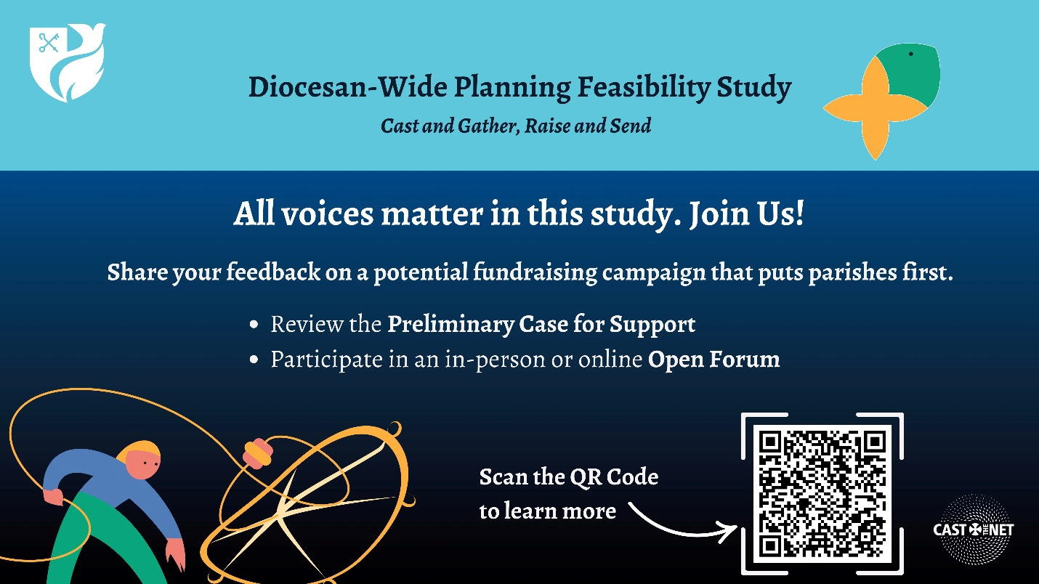
Image sized for social media (1080x1080). Right click to “save as picture”.
